Sneak Previews, portrait of Jesus and Song - rough
September 18, 2016
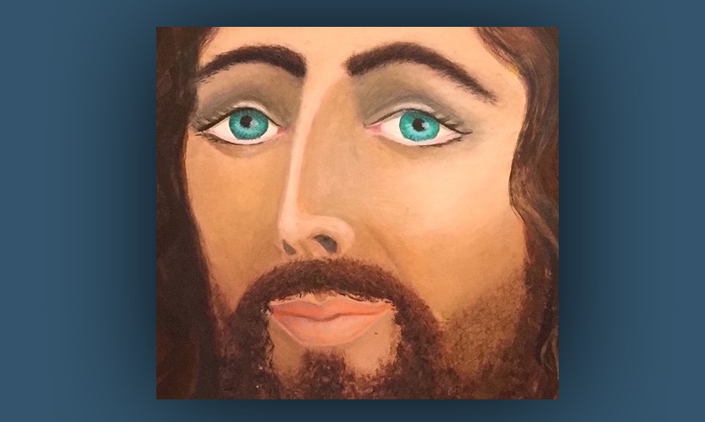
Well, my precious Family, I just couldn't resist. Knowing that I tend to be a perfectionist, and that I have quite a bit more work to do on this song and on the portrait. The Lord asked me to put the two together.

And rather than deprive you of at least a HINT of what He had in mind for both the song and the portrait, I decided to share it with you, even though it's not finished. Just a little bit of it. It's not a full size, it's just a little snippet. It's the essence of how He feels, it's His eyes you know, that are so important.

In case you're wondering, He's the one who put the lilt to His eyebrows, because I was going to do them normally. The proportions pretty much fit the Shroud of Turin. But one night, out of frustration, I asked the Lord, "Please, help me!" And Ezekiel anointed me and prayed behind me. And all of a sudden, these eyebrows came into being and this expression came - and it was the Lord. And I knew it was the Lord.

The first picture was kind of cartoonish, and I tried to change the eyebrows, 'cause I thought, 'Well, that's kind of funny. I don't know if I really want them that way...' And when I did, I messed it up. So I changed it back again to what He wanted. And I'm just resting in that.

But I still have a lot of work to do on His hair and the background and His shirt and everything. So, it's going to take a little bit of time more. But I wanted to share with you the sweet, sweet expression that He has on His face. And I also wanted to share the song with you, which I'm still working on with the piano with broken chords. So, I'm going to ignore the perfectionism and I'm gonna just sing it for you. Just so you can get an idea of the message that He had in mind, to go with the portrait.

I love you,
Oh, how sincerely I love you.
Oh, how securely I hold you to My heart.
Hoping only for your trust in Me,
Trust in Me, in Me.

I need you,
Although I'm God I still need you.
For Who I Am when you praise Me,
From your heart.
For the ones who've turned away from Me.
Oh, comfort Me, comfort Me.

I love you,
Lean on the One in love with you.
I hear you searching and calling out to Me.
I'm here, right here, oh can't you see?
It's truly Me. Look at Me.

I'm waiting for you,
When you ignore Me you wound Me.
When you forget all that I have promised you,
That together we shall do.
And you question if My words are true.
I promised you, promised you.

That's the first draft of the song. And I'll get my voice in order and get the piano in there. And I just couldn't resist sharing a little bit of what He's been working on.

